Answers to these questions and teacher support can be found in the accompanying Guidance Notes.

Challenge 1: Understanding smart meters

Introduction
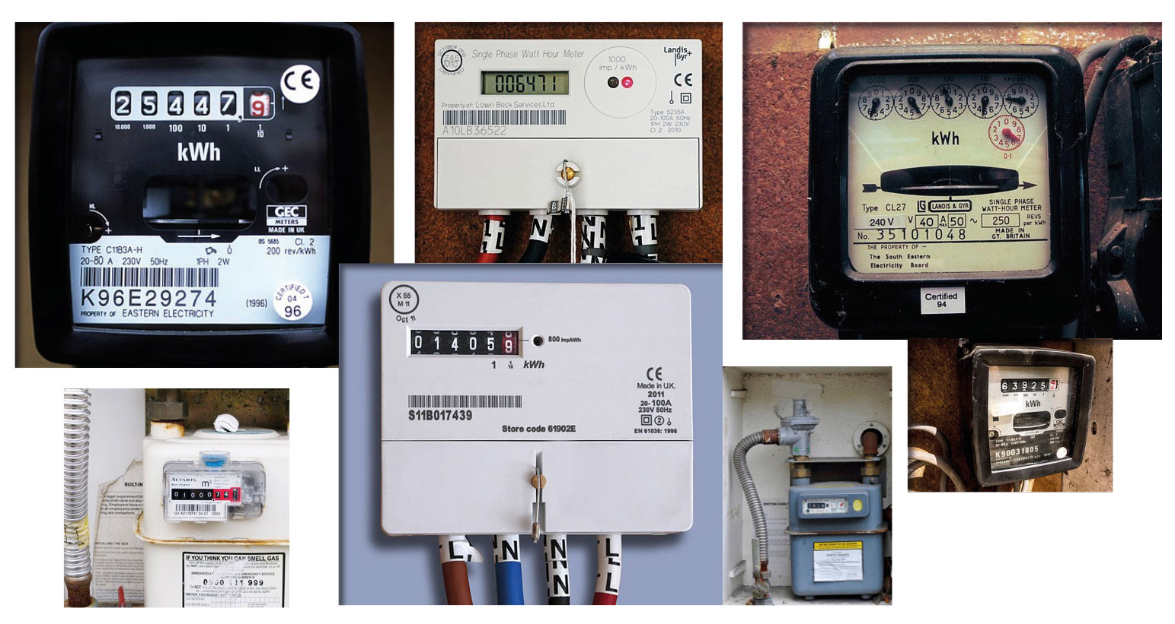

Fact finder
Below are three websites that you can visit to find out more about smart meters. Use a search engine to find a fourth website to use – make sure it’s one that’s credible – and add the URL to the list below.

https://www.smartenergygb.org/en
https://www.gov.uk/guidance/smart-meters-how-they-work
https://www.ofgem.gov.uk/gas/retail-market/metering/transition-smart-meters

Q1. Use the web links to answer the following questions:

a) What are smart meters?

b) When will smart meters be fitted?

c) Give TWO benefits of smart meters.

The explainer
Can you use your vocabulary and knowledge about smart meters to explain what they are to three different audiences? Remember to think about what each of the audiences will be most interested in and use this to inform your answer.

Q2. A younger brother, sister or relative.

Q3. A parent.

Q4. An elderly neighbour.

True or false?
Can you identify which THREE of these six sentences are FALSE (circle the FALSE answers)?

- Smart meters were invented in 1792.
- Smart meters let you see in real time how much gas and electricity you’re using in pounds (£) and pence (p).
- You need to pay for a smart meter to be installed.
- A trained installer will put in your new smart meter.
- The government will be rolling out 53 million gas and electricity meters.
- You must have a smart meter installed by law.

Smart meter editor
Here’s some information from a Government website on smart meters. Can you use your knowledge about paragraphs and how to write headlines to break up the text and make it easier to read?

Smart meters are covered by UK and EU product safety legislation, which requires manufacturers to ensure that any product placed on the market is safe. Public Health England (formerly The Health Protection Agency) provides advice and information on the health implications of smart meters, as it does for a range of technologies commonly found in homes and businesses across the UK. Public Health England has advised that the evidence suggests that exposures to the radio waves produced by smart meters do not pose a risk to health. Further information about smart meters and health. All homes and small business sites will be offered smart meters by their energy company between now and the end of 2020.

What have I learnt?
Write a short sentence to describe what you have learnt about smart meters.

Turn to the next page for some maths challenges…

Challenge 2: The energy-saving benefits

The in-home display that comes with a smart meter shows you lots of useful information about your energy use, including:
- How much energy you’re using at that moment (this could include electricity and gas – or just one of them).
- How much it costs.
- How much you’ve used in the past, so you can see those dates and times when you’ve used lots of energy and those days when you’ve used less.
- You can even see how much it costs to use different electrical items. For instance, if you turn on a light, you should see the number on the monitor increase on the screen.

When do we use the most electricity?
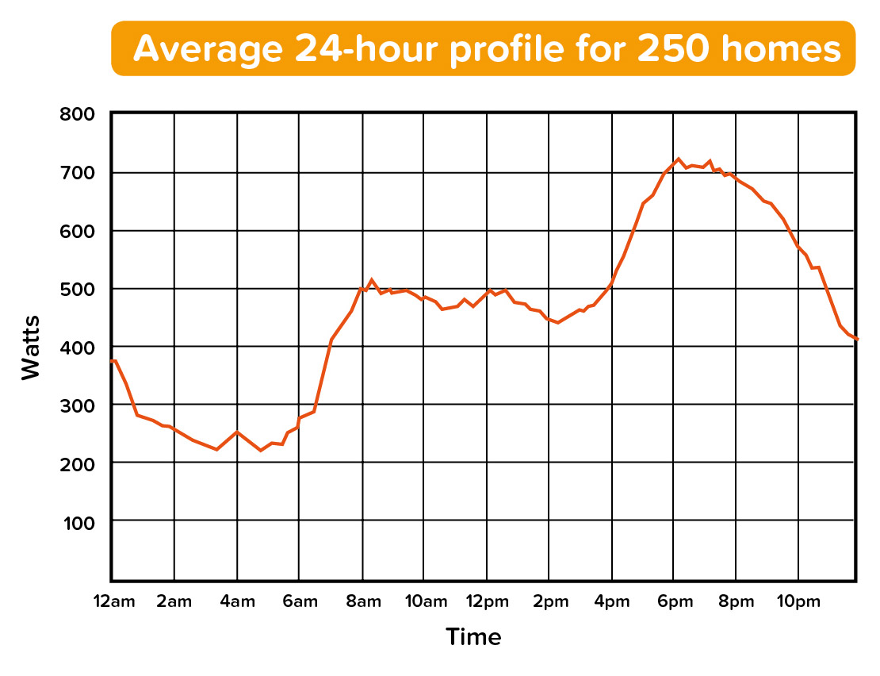

Q1. Look at the graph on the previous page∗. When are the two periods of the day when we use the most electricity? (Clue: look for the two biggest ‘humps’ on the graph.)

Q2. What are you usually doing at these times at home? Why do you think we use so much electricity at these times? Write your answer in the box below.

Turn to the next page for more maths questions…
Working out your electricity use
There is a light on the top of the in-home display that shows whether you’re using a high (red), medium (amber) or low (green) amount of energy*. The kW number at the top of the screen shows you exactly how much electricity you’re using at that moment in time, and this is also shown by the coloured dial (green (low), amber (medium) and red (high)). The bottom half of the screen shows you how much your electricity costs.
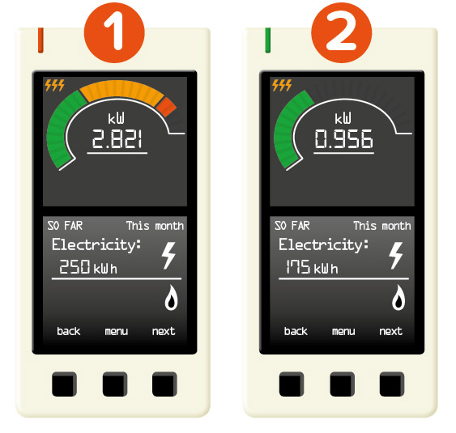
Q3. In-home display 1 shows the electricity use by a household that uses lots of electricity. The top part of the screen shows their current use, while the bottom half of the screen shows how much they’ve used so far over the past month.
In-home display 2 shows how much electricity has been used by another household the same size, but which is more energy efficient.

Continued on the next page…
What’s the difference in the two families’ electricity use in the past month? (Clue: subtract the figure at the bottom of in-home display 2 from the figure at the bottom of in-home display 1.)

Q4. Electricity is measured in kWh and energy suppliers have a cost for 1kWh, which they use to work out the cost of the electricity you’ve used. If 1kWh is equivalent to 15p∗ how much is the cost of electricity used by the household on the in-home display 2? (Give your answer in pounds and pence).

Turn to the next page for more maths questions…
The cost of gas
As well as showing you how much electricity you’re using, the in-home display shows how much gas you’re using too. Gas is indicated by a blue coloured dial (instead of the green/amber/red dial for electricity use), and the larger the dial, the more gas is being used. The kW number at the top of the screen tells you exactly how much gas you’re using at that moment in time, while the bottom half of the screen shows you how much your gas costs.
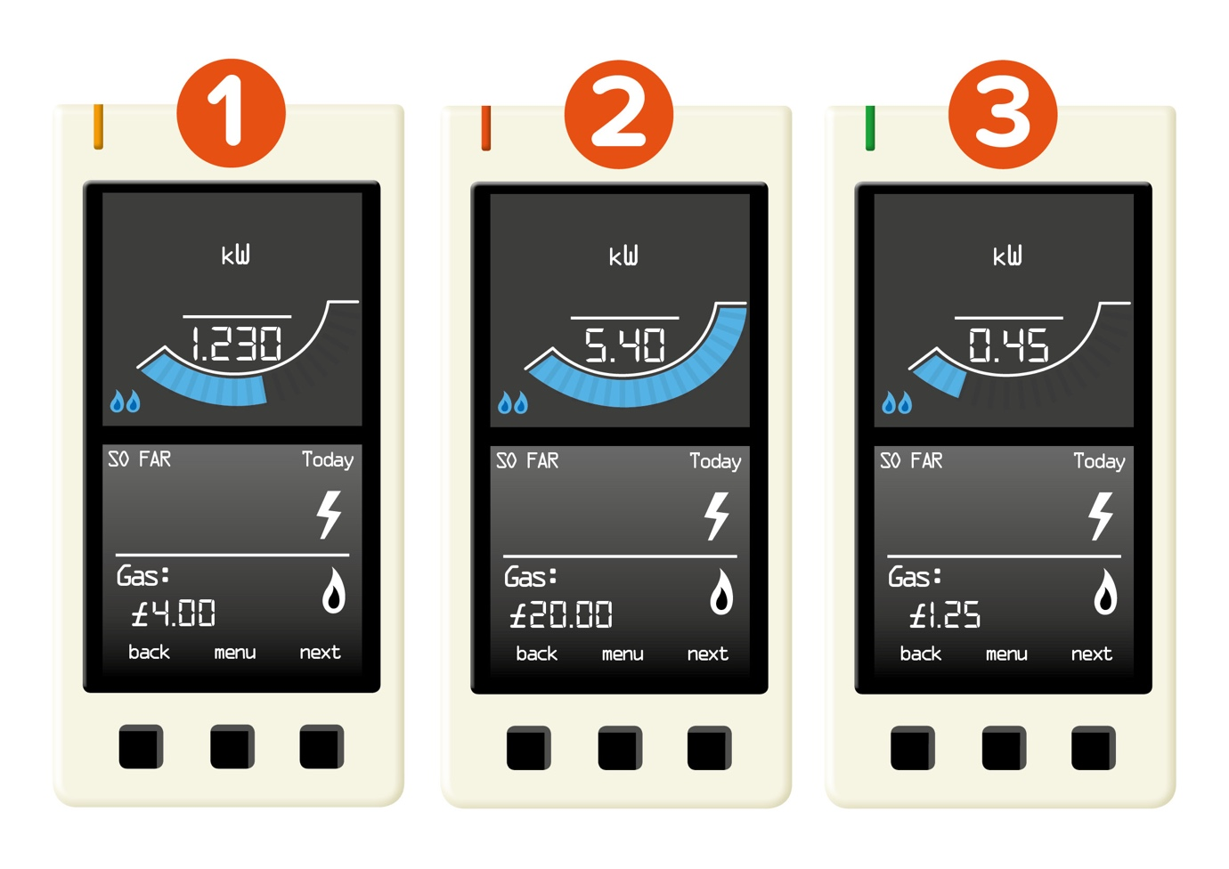
Q5. Look at in-home display 1. How much has your gas cost so far today?

Q6. If the gas you used yesterday cost £4 and you used the same amount for one week (7 days), how much would your week’s gas cost?

Q7. If you used the same amount of gas for one month (assume 30 days), how much would your month’s gas cost?

Q8. Compare in-home displays 1 and 2. Assuming both readings were taken at the same time on the same day, what’s the difference in cost between the two houses?

Q9. Can you express the amount shown on in-home display 1 as a fraction of the amount shown on in-home display 2?

Q10. Look at in-home display 3. How much has this home’s gas cost so far today?

Q11. If the extra gas used over the rest of the day costs £1.15, how much will your gas have cost in total? (Clue: £1.25 + £1.15)?

Q12. If the extra gas you use over the rest of the week costs £16.75 how much will your gas have cost in total? (Clue: £1.25 + £16.75)

Turn to the next page for more maths questions…
How much electricity do we use in a day?

Q13. Here’s a table showing how much electricity a home has used over a day. Can you work out the total amount of electricity used and write it in the space below?

Time | Midnight–6am | 6am–12pm | 12pm–6pm | 6pm–Midnight
Electricity used (kWh) | 8 | 16 | 16 | 8
Cumulative electricity use (kWh)
Total:

Q14. Use the table to create a bar graph below to show how much electricity this home has used over the day.
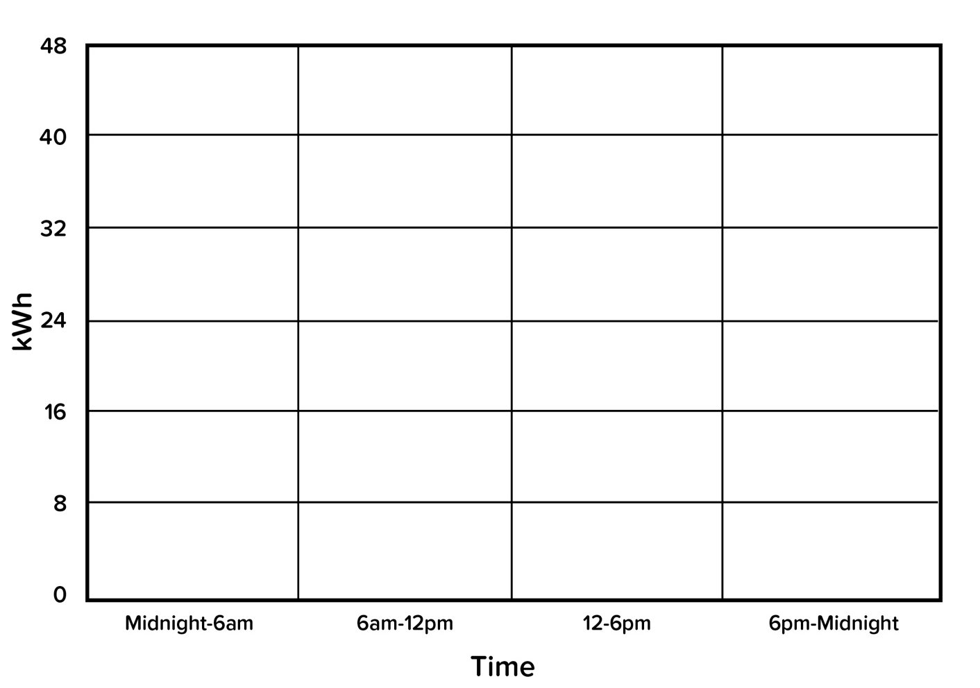
Q15. Now add a line graph over the top to show the cumulative electricity use over the day (i.e. how much electricity in total has been used – you could use the blank row in the table above to add up the totals).
How much electricity do we use in a year?
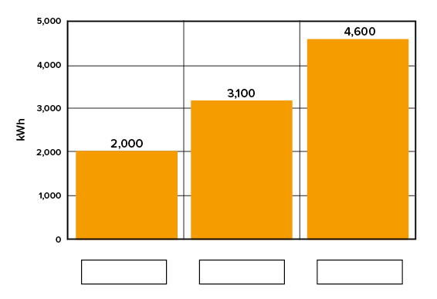
This graph shows the amount of electricity a home might use over a full year*:
- 2,000 kWh is classified as ‘low’ electricity use
- 3,100 kWh is defined as ‘medium’ electricity use
- 4,600 kWh is defined as ‘high’ electricity use
Q16. Fill in the blank spaces below the graph for Low / Medium / High.

Q17. Obviously how much electricity and gas a home uses varies – some families use lots of energy, while others don’t use much at all! But which of these labels (Low / Medium / High) do you think might apply to:
- A four-bedroom house with a family of 5?
- A one-bed flat with two people living in it?
- A three-bedroom house with a family of 3?

Challenge 3: Changing behaviour

The top of the in-home display has a light that turns red (high), amber (medium) or green (low) to show how much electricity or gas we’re using right now. We can use this to identify when we’re using more electricity and gas than usual – the light will be glowing red – and think about what actions we can take to use less energy during these times. This could reduce the amount we pay for electricity and gas (as we’re using less) and it’s also good news for the planet if everyone uses less energy.

Saving energy

Q1. Write down TWO things you could do to use less energy (electricity and gas).

Q2. Write down TWO things your family could do to use less energy.

Q3. Write down TWO things children (and teachers!) at school could do to use less energy.

Take action

Now you’ve learnt about the importance of saving energy, why not share what you’ve learnt with others? Write an email to your family persuading them to use less energy at home. Include practical suggestions (e.g. ideas for how to do this) and format the email so it’s easy to read (e.g. include bullet points, hyperlinks to useful websites etc.) If you need some pointers, these handy tips might offer some inspiration: jointhepod.org/energyathome

Extension activity: Smart meter facts

Q1. My two favourite smart meter facts are…

Q2. Research two of your own smart facts and write them in the box below. Use a search engine or one of the links on page 1 to find them and include the web links below. Remember to make sure the websites you use are safe and credible.

If you’re inspired to save energy, go on a hunt around school in our Vampire Slayer quick activity!
(www.jointhepod.org/vampireslayer)

∗Source: https://www.gov.uk/government/uploads/system/uploads/attachment_data/file/275484/electricity_survey_2_tuning_in_to_energy_saving.pdf (page 2)
* The pictures show one type of in-home display; other models are available
∗ As of June 2017: https://www.ofgem.gov.uk/publications-and-updates/infographic-bills-prices-and-profits
* https://www.ofgem.gov.uk/gas/retail-market/monitoring-data-and-statistics/typical-domestic-consumption-values

